**Strengthening Federation-wide Institutional**

**Preparedness and Readiness within the Disaster Risk Management system**

OBJECTIVE

The objective of this concept note is to establish the frame in which the IFRC secretariat will equip itself with the right tools and culture to increase its operational readiness with and alongside the Membership. Specifically, it seeks to enhance the coordination within the preparedness and readiness spaces, agreeing on standards, terminology, approaches, and tools, identifying synergies and complementarities between IFRC and RCRC components, establishing more consistent and coherent mechanisms to monitor and prioritize readiness gaps, and offering tangible support to National Societies, IFRC Delegations and Regions to enhance collective readiness for timely and quality responses.

SCOPE

While preparedness and readiness involves many actors at community, local, national, regional and global levels, the planned objectives for this initiative will focus primarily on the institutional preparedness and readiness of the IFRC secretariat and its Membership. As such, through concrete recommendations, practical actions, and standard-setting, this initiative plans to increase institutional readiness to foster a stronger preparedness and readiness culture within the IFRC and Membership and an enhanced ability to respond, with quality, when the time comes.

GUIDING DOCUMENTS

This concept note has been developed considering guidelines, principles and strategic documents where preparedness and readiness are clearly highlighted, for example:

* [The Fundamental Principles of the Red Cross, Red Crescent Movement](https://www.ifrc.org/who-we-are/international-red-cross-and-red-crescent-movement/fundamental-principles)
* [Strategy 2030](https://www.ifrc.org/who-we-are/about-ifrc/strategy-2030)
* [RCRC Principles and Rules for Red Cross Red Crescent Humanitarian Assistance (2013)](https://www.ifrc.org/document/principles-rules-humanitarian-assistance)
* [Disaster Risk Management Policy](https://www.ifrc.org/document/disaster-risk-management-policy)
* [National Society Preparedness framework](https://ifrcorg.sharepoint.com/:b:/s/IFRCSharing/EQ5UanP3dvhCnbqS6DlvNiIBqigl6vdM7b_3rIXnIjAIbw?e=b3wlKg)
* [Preparedness for Effective Response (PER) Approach](https://ifrcorg.sharepoint.com/:f:/s/IFRCSharing/EgZ-8br2x6tPu1Zx53mOhPABdTYFroJQDAUpJY_QICfw2g?e=I735fb)
* [Seville agreement 2.0](https://www.ifrc.org/document/seville-agreement-2)
* [Sendai Framework](https://www.undrr.org/publication/sendai-framework-disaster-risk-reduction-2015-2030)

THE HUMANITARIAN LANDSCAPE AND CASE FOR READINESS

The humanitarian response landscape is undergoing significant transformation due to an increase in the frequency and intensity of disasters, conflicts, and public health crises, driven by factors such as climate change, geopolitical instability, and global pandemics. The rise of complex emergencies has highlighted the importance of localizing aid efforts, requiring enhanced collaboration, resource-sharing, and capacity-building to ensure timely and context-specific interventions. Furthermore, technological advancements and data-driven decision-making are reshaping response strategies, emphasizing the need for agencies to adapt to new tools and methodologies to optimize their effectiveness in rapidly changing environments.

IFRC Red Cross Red Crescent membership is committed to continue improving and maintaining its capacity to immediately activate the national, regional and global response system in response to crisis and disasters to provide humanitarian assistance. Preparedness a readiness measures play a key role to ensure IFRC ability to quickly and effectively response in line with the RCRC Principles.

The humanitarian landscape is changing, according to the IFRC [World Disaster Report 2022](https://www.ifrc.org/sites/default/files/2023-03/2022_IFRC-WDR_EN.0.pdf.pdf), several lesson were reported as part of the COVID-19 pandemic response which underscored the importance of preparedness based on the principles of trust, equity, and local action. At the same time, it was highlighted that true preparedness means being ready for multiple hazards, and not just one, considering that the world is becoming increasingly hazardous.

We must be prepared for future climate related crises and environmental emergencies, and we must also be ready for a changing world with more humanitarian constrains. Below the main trending humanitarian challenges:

* **Climate change and environmental crisis**: Climate change is undeniably one of the most significant threats to humanity’s future and is a major driver of humanitarian crises today. IFRC data indicates that in the past ten years, 86 percent of all disasters triggered by natural hazards were caused by weather and climate-related events.
* **Disasters and Crisis**: The world is expected to experience around 560 disasters annually by 2030, with climate change and disasters pushing an additional 37.6 million people into extreme poverty. A worst-case scenario could result in an additional 100.7 million people living in poverty by 2030. Inequality, poverty and discrimination contribute to growing disaster risk, and disasters disproportionately affect the most vulnerable, deepening inequalities.
* **Protracted crisis and complex emergencies:** In 2022, an estimated 406.6 million people living in 82 countries were assessed to be in need of humanitarian assistance. Of those 82 countries, 44 of them were experiencing some type of a protracted crises accounting for 83% of the total number of people in need in 2022. Key drivers of complex crises in 2022 were climate related (such as drought or flooding), and situations affected by conflict and socio-economic fragility
* **Health and wellbeing:** Before the COVID-19 pandemic, global health indicators had already shown signs of slowing progress. Unfortunately, the pandemic exacerbated these issues, straining healthcare systems and exacerbating disparities. Non-communicable diseases (NCDs) account for 70per cent of global deaths and disabilities in lowland middle-income countries (WHO, 2023). Health resilience in the coming decade will be tested by factors like population movements, epidemics, conflicts, NCDs, disasters, technological risks and climate change.
* **Migration and Displacement:** Displaced people require immediate protection and assistance, including shelter, healthcare, safe water, sanitation, food and nutrition. Beyond these immediate needs, support for durable solutions such as return, local integration or resettlement is crucial. The number of refugees and IDPs worldwide increased significantly. Conflict, violence and disasters force people to flee both across borders and within countries.
* **Values power and inclusion:** The COVID-19 pandemic underscored the importance of information sharing and building trust, highlighting the critical need for effective communication in crisis response. Protection risks, including sexual and gender-based violence and human trafficking, intensified during the pandemic.

In line with the Agenda for Renewal and the global community’s commitment to localization, a core element of the IFRC and Membership’s future within such a dynamic response landscape relies on stronger operational preparedness and readiness with HNS, PNS, and IFRC delegations. Doing so, will support the clearer roles and responsibilities, stronger capacities and better ensure a common understanding of the added value that the IFRC and Membership bring to a response.

Preparedness and readiness have been the subject of interest and investment within the IFRC and Network for many years, including as the core responsibilities of the Regions and Delegations in their emergency management portfolios. As such, many initiativeshave been mounted in this space. The Preparedness for Effective Response (PER) approach has long sought to enhance the preparedness and readiness of National Societies, having established a comprehensive, global NS [preparedness framework](https://ifrcorg.sharepoint.com/:f:/s/IFRCSharing/EipPGOVKBblPql-XsR4CDt0BSaNits_2vCE059EAzE4Rug?e=0E8ddT) against which our Membership have been building their capacities for years. In January 2024 the first version of the delegation readiness checklist was released to support IFRC country and cluster delegations to ensure their essential readiness for emergencies. Similarly, the IFRC Asia Pacific Region went through a comprehensive exercise to increase their regional readiness by developing clear institutional processes to follow at regional and country levels in providing support to NSs in emergency situations. Globally, because of the 2023 Global Surge Working Group, the Surge team has just released a discussion paper seeking to expand the scope of rapid response personnel and use them to enhance readiness across the IFRC and Membership.

While these are important initiatives that, in many ways, establish a standard for the IFRC and Membership’s collective approach to readiness, they represent only a few of many separate initiatives that seek to address similar problem sets of ensuring our ability to respond when the time comes. In as much, the IFRC seeks opportunities to better understand the reach of its collective readiness and the impact these many initiatives have had on enhancing its global disaster management system. A better understanding of our collective reach will support identification of where the where the most significant gaps remain and where investment should be prioritized.

At the same time and as is happening in the whole IFRC system, in the Africa region the concept of preparedness and readiness at NS and Secretariat levels is in the language and terminology we are using now but it needs further development on how to integrate and/or articulate it across the DRM continuum in the preparedness, response, readiness and contingency plans of both NS and IFRC Secretariat. Ultimately, there is a need for a more coordinated and coherent approach to preparedness and readiness to ensure a common understanding of the terminology and different approaches, to map and harmonise the different initiatives and to- ensure a common foundation for preparedness and readiness, which informs standards, opportunities, and priorities to enhance institutional readiness.

CONCEPTUAL FRAMEWORK

According to [IFRC Disaster Risk Management Policy](https://www.ifrc.org/sites/default/files/2022-05/20210127_IFRC-DRM-EN%5B1%5D.pdf) “from prevention to response and recovery”, Our top priorities in disaster risk management are to save lives, reduce suffering, and uphold human dignity. The policy highlights in the third commitment the important to **strengthening organizational preparedness** promoting and carry out – pre disasters meetings and agreements, **response and readiness plans** at national and regional level ensuring participation of internal and external stakeholders.

While preparedness address holistically a wide range of activities, readiness ensures that an organization can respond quickly and effectively to emergencies, both concepts are intrinsically connected and cannot be separated due the interdependency in developing solid foundation (preparedness) and responding quickly (readiness). The graphic below shows the DRM continuum and how preparedness and readiness measures can help RCRC members to effectively respond to disasters and crisis.

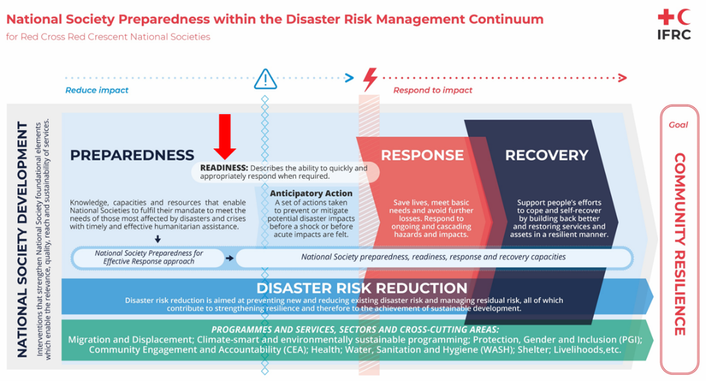

DEFINITIONS

For purpose of this document, the following concepts and definitions applies:

**Preparedness**

* **Definition:** Preparedness refers to the knowledge and capacities developed by governments, response and recovery organizations, communities and individuals to effectively anticipate, respond to and recover from the impacts of likely, imminent or current disasters.
* **Scope:** Preparedness is broad and holistic, covering a wide range of activities that include risk assessments, developing emergency plans, community engagement, and awareness programs, stockpiling resources, and establishing partnerships and coordination mechanisms. The scope of preparedness is broad and multifaceted, encompassing a range of activities aimed at ensuring readiness to respond to disasters and emergencies at the national level.
* **Objective:** The primary objective of preparedness is to establish mechanisms and procedures that reduce the risk of disasters and ensure that communities, organizations, and governments can effectively mitigate the impact of disasters when they occur.

**Readiness**

* **Definition:**
* **Scope:** The scope of readiness is narrower, focusing on the immediate availability and deployability of resources, personnel, and systems. It ensures that all elements necessary for a response are in place, functional, and can be activated quickly.
* **Objective:** The objective of readiness is to ensure that an organization can respond quickly and effectively to emergencies, minimizing response time and maximizing the efficiency and effectiveness of the response efforts.

# BUILDING AN INSTITUTIONAL CULTURE OF PREPAREDNESS AND READINESS

A culture of readiness embodies not just preparedness but a willingness to move towards something different in the humanitarian landscape with a shared acknowledgement of the need to have a common approach and vision as humanitarian organization. To build a culture of institutional preparedness and readiness, RCRC actors require to continue working and practicing joint actions and shared responsibilities to:

* Better understanding of the future and predictability of the humanitarian landscape
* Institutionalizing joint pre-disasters meetings (Hurricane season, Typhoon season, heatwaves, droughts, population movement etc.)
* Increasing joint simulations exercises in regular basis (national, regional and global)
* Developing Federation-wide contingency plans for specific hazards
* Developing and implementing institutional readiness plan at all levels
* Implementing regular check on the level or readiness for IFRC and PNS Delegations
* Investing on early actions initiatives based on scientific and community knowledge
* Accelerating the localization agenda, including pre-disasters agreements between neighbours NS, sub regional DM mechanisms etc.
* Re-adjusting or creating emergency protocol to increase our agility to response

An enhanced culture is founded on a common understanding of and standard approach to preparedness and readiness across the IFRC and Membership at the country, regional, and global levels. By adopting standardized protocols and guidelines, the IFRC and its member National Societies can rapidly mobilize resources, coordinate actions, and share best practices. This standardization facilitates training and capacity-building initiatives, enabling volunteers and staff to operate seamlessly within and across borders, which is particularly vital in regions like Asia Pacific, where the diversity of languages, cultures, and disaster risks presents unique challenges.

RCRC PREPAREDNESS AND READINESS INITATIVES

In line with the context analysis, needs and RCRC mandates, several preparedness and readiness initiatives are ongoing, for example (see more details in annex 1):

International support

PNS

* PNS standing teams

Preparedness plans for PNS Offices

IFRC Secretariat

* IFRC Secretariat Standby list
* IFRC Secretariat Emergency Response Framework
* IFRC Secretariat Operational readiness checklist
* IFRC secretariat Asia Pacific Regional Readiness plan
* DREF for imminent crisis and disasters
* Americas Pre-hurricane meeting
* ERU readiness and optimization
* Rapid Response Personnel for readiness activities

National Society

* NS Preparedness framework and its NS Preparedness for Effective Response common approach.
* Regional NS Preparedness and Readiness – regional statutory Pan African Initiative and Hanoi Call for action
* NS Preparedness and readiness initiatives, projects, programmes supported by PNS, IFRC, ICRC, externals
* Large-Scale Disasters initiative in East Asia

OPPORTUNITIES

Fostering such an initiative presents several benefits and opportunities for the IFRC and Membership:

* **Agree common terminology** for NS and secretariat preparedness and readiness,
* **Stronger interagency coordination** on preparedness and readiness
* **Map** the different initiatives and approaches ongoing between IFRC units and divisions as well as within the Network:
  + to **align our understanding** of preparedness and readiness
  + to **harmonize** relevant approaches and identify synergies[1]
  + to **identify gaps** and opportunities
  + Identify and seek **funding** opportunities,
* Establish **approach and clear process** for IFRC and Network to support coordinated, collective and coherent preparedness and readiness,
* **Build synergies** between components and layers of the Red Cross Red Crescent and Secretariat to provide tangible offers of support in enhancing IFRC and NS readiness
* Leveraging the collective power of the IFRC and Network, **identify funding opportunities** to support readiness-building efforts in the most priority areas

As priority, the following actions are recommended to be implemented to realize those opportunities.

* **Creation of a core working group** integrated by National Societies and IFRC Secretariat which the main objective to identify the mains gaps in the coordination, maps the different readiness initiatives and propose practical actions to roll-out institutional preparedness and readiness actions. Specific terms of reference will need to be developed collectively among the IFRC membership.
* **Convene global institutional preparedness and readiness workshop/meetings** to agree the collective direction and strategic actions to enhance RCRC institutional preparedness and readiness, including standardization, harmonization and collective vision and approach.
* **Develop and rollout the institutional operational readiness:** to build capacity within the IFRC to be better prepared and more ready to implement existing rules and processes when a disaster or crisis occurs

# ANNEX 1

## EXTRACT FROM REPORT FROM SECREATARIAT PREPARDNESS AND READINESS SESSION IN NAIROBI

**Session 1: Preparedness and Readiness**

Discussion: A strong consensus emerged on the need for improved alignment and clarity in the use of preparedness and readiness terminology across the IFRC and Network. This alignment is essential to avoid confusion, duplication, and to build a cohesive narrative that can drive investment and support for these initiatives.

A key focus was the importance of positioning National Societies as pivotal actors within national and global disaster preparedness strategies, reinforcing their value and visibility in system-level disaster response efforts. However, challenges were noted, including inconsistent terminology, unclear expectations for new HoD’s regarding their roles in NS preparedness, including who holds responsibility and accountability for readiness within our system, and the underutilization of available resources, such as the information on IFRC GO.

Despite these challenges, significant opportunities were identified. The IFRC can leverage seasonal readiness activities—such as the pre-hurricane conference in the Americas—as models for systematic preparedness, embrace "Systems Strengthening" terminology to better promote NS within national disaster management systems, and enhance learning from UN, INGO, government, and academic partners. This renewed focus on readiness offers the chance to better integrate National Societies within the broader humanitarian architecture and to cultivate a stronger Federation-wide culture of preparedness and readiness.

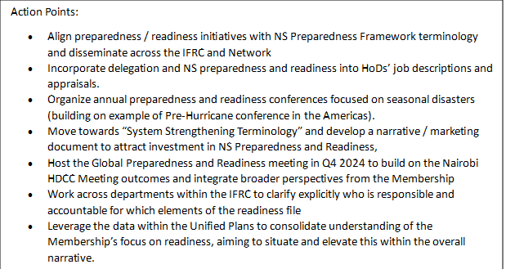

## DCWG 2023, READINESS MAPPING

|  |  |  |
| --- | --- | --- |
| **Who** | **What** | **Contact** |
| MDA | Ambition for contingency planning for regional EQ between PRCS, Jordan RC, MDA (together with IFRC, PNS, ICRC). Many challenges due to political and technical reasons. | Chaim Rafalowski |
| Danish RC | DRC has a preparedness and contingency framework for all country offices. Reached out to all IFRC offices asking them to be part of it. Also looking at supply chain, programming, pre-disaster agreements. | Bjarke Skaaning |
| Hong Kong RC | PER framework used for HK RC. Forecast-based action project in Asia-Pacific. Newer concept (start by focusing on slow onset disaster). Participation in AP Dialogue Platform on Anticipatory Action (Anticipation Hub/German RC).  Domestic – community-based program to train community volunteers. Building capacity to respond to disaster. | Stella Tsang, Joyce Ching |
| Austrian RC | AutRC Regionalisation in Eastern Africa to build regional WASH capacities. | Andrea Reisinger |
| Australian RC | With IFRC: Revision of the Red Ready for AP, ECHOP PPP, Global Data Bank (big project).  Surge- barriers to local surge, deployment funds to quickly deploy local staff, safeguarding initiative. Also leadership program, cleaning of surge database.  Australia RC: Epidemics preparedness project (Indonesia, Myanmar, Fiji, etc.) Prepositioning of stocks especially in the Pacific (decentralised ones and a central one in Brisbane), Quick funds envelope to be released. | Sophie Ford |
| Swedish RC | Since 2022 Swedish RC has a type of crisis modifiers funds with money already available at country level in case of disasters.  Project “ready to respond” working with specific NS active in the WASH sectors (related to capacity building in terms of logistics, warehouses, competencies, etc.) | Mari Morth |
| German RC | General preparedness to ensure preparedness of ERU (i.e., harmonization, roster update, etc…)  Pilot simulation exercise in Cabo Delgado (Mozambique) on request of ICRC to increase readiness of NS volunteers. Possibly to be replicated in other contexts.  Preparedness in technical fields: designing trainings for NS based on specific request = IPC training in Colombia and Venezuela, also WASH in Honduras. | Arno Waizenegger |
| Belgian RC | Further development of ERU readiness. | Havard Jakob Hoe |
| American RC | Mainstreaming cash into relief ERU. | Anne Reynolds |
| Norwegian RC | Harmonization of ERU with ICRC so ready to deploy with ICRC. Going through ICRC vetting process. | Marcus Bolleurs |
| Finnish RC | Evacuation ready for Baltic countries. Building on program of Baltic Preparedness (EU funded). Updating agreement with gov (domestically). MoU with Minister of Defense. Internationally promoting PER (with focus in Africa). Did internal exercise with support services and non-DM services to identify what is their role in an emergency and then explore what is the minimum services that must continue. Output preparedness plan for their unit and SOPs. The end goal is for them to realize their role in emergencies. Process helps show they are part of the emergencies (shift mindset). | Marco Korhonen |
| Canadian RC | Changing the way we onboard delegates so that they are more ready to respond – for example exploring shadow missions, developing opportunities to ensure better success while deployed. | Emma Sturrock |
| IFRC Secretariat | HQ: ForeSEE project looking at IFRC secretariat readiness, and Operational Readiness role (workplan available.)  HEOPs: Readiness of the pool. Redesign re-certification of the program. Try to ensure people are ready, which means having the needed equipment, knowing Seville 2.0, knowing IFRC procedures, etc. Looking at simulations to help in HEOPs readiness. | Jennifer Breckenridge  Jamie Le Sueur |
| Utilization of the HEOps and DHEOps network to support priority and at-risk delegations to enhance their operational readiness using the secretariat readiness checklist | Jamie Le Sueur |
| Support the dissemination of key IFRC policies and procedures (Seville 2.0, Principles and Rules, etc.) and support relevant delegations with the establishment of their Movement Cooperation Agreements (MCA) |  |
| AP region: Large-scale disasters initiative (in AP Region – Japan, China + IFRC): cooperation on level of preparedness/readiness in case of large scale disasters.  AP DM Network: preparedness, DCWG type of meeting for Pacific with preparedness/ readiness as an item. | Felipe Del Cid |
| Surge for readiness and surge for preparedness discussion papers looking at how to better utilise existing roster of Rapid Response personnel to support preparedness and readiness. | Francisco Maldonado |
| Development and rollout of the operational readiness checklist at Delegation, Regional, and HQ-levels | Jennifer Breckenridge |

1. Discuss the Asia Pacific readiness approach with other Regions to ensure a common understanding of what an ‘operationally ready’ Region is, supporting each to enhance their own readiness.